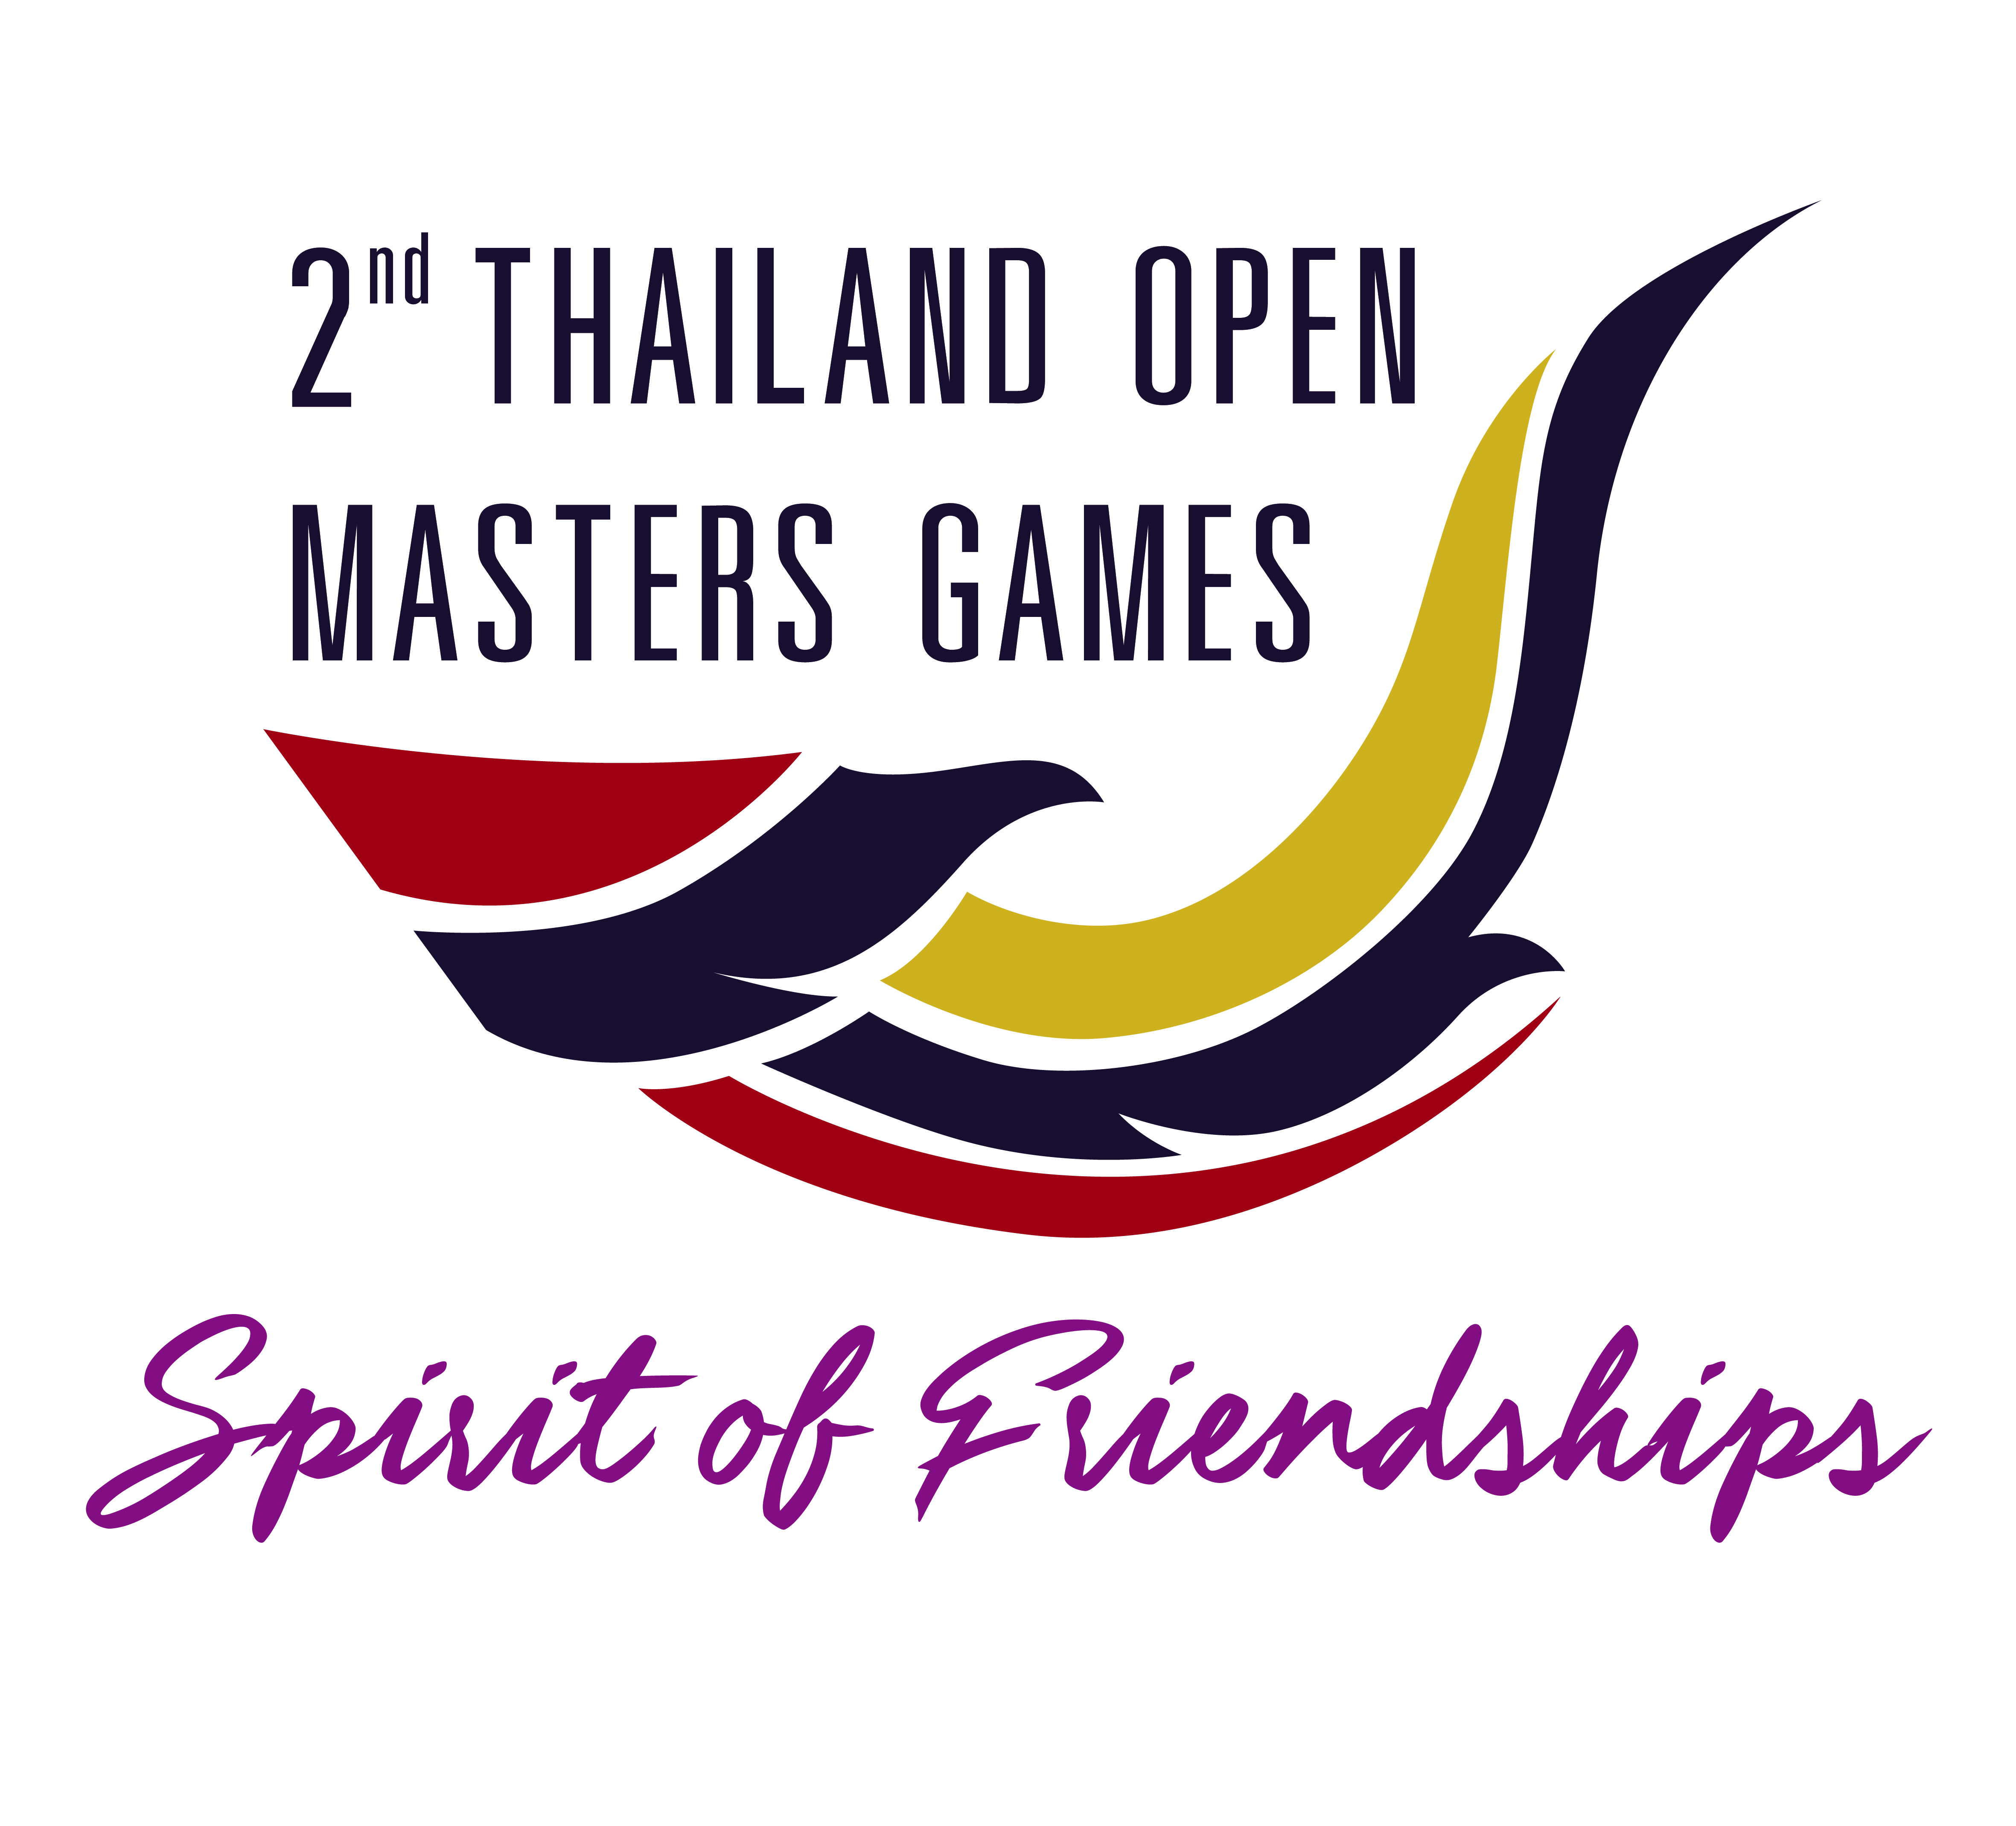
Application Form
Badminton
2nd Thailand Open Masters Games
12 - 16 January 2022, Songkla Province, Thailand
Name, Surname | Age(Years) | Membership | Event | Grade

- Registration Fee : 300 Baht (10 USD)
- Enter Fee : 500 baht/person/event
- Please complete the entry form and attach a copy of passport and email to thailandopenmasters@gmail.com by Friday Dec 17, 2021 at 20.00 hours Bangkok time.
- Please do the bank transfer of entry fees when you apply the tournament
- The entry will not be confirmed until the payment received.

Payment information
Bank name : Kasikorn Bank
Account Name : Badminton Association of Thailand – Paypal
Account number : 020-8-83619-6
Swift Code : KASITHBK
Branch : All Season Place

