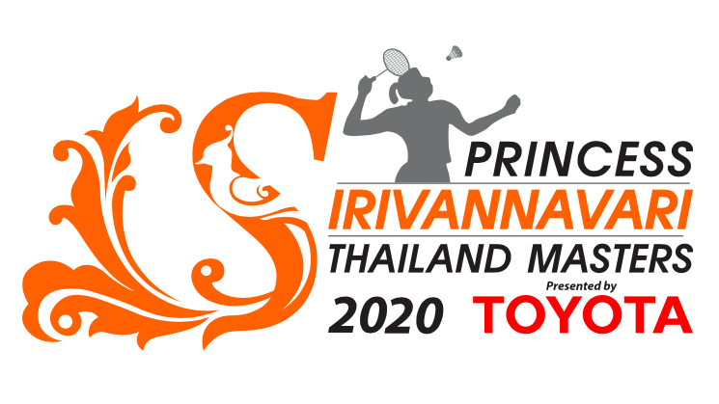
Princess Sirivannavari Thailand Masters 2020 Presented by TOYOTA
Media Accreditation Form

- ข้อมูลส่วนตัว
Name
Surname
ID/Passport Number
News Agency
Address
Tel :  Fax : |  |  | Email
[ ] Newspaper |  |  | [ ] Magazine
[ ] Radio/TV |  |  | [ ] Others……

2. Position (Select only 1)
[ ] Journalist | [ ] Photographer | [ ] Broadcaster
[ ] Others….

3. Photo
[ ] Attached photo with name
4. Others
Please attached
[ ] Media ID
[ ] Letter appointment from company/agency
Please fill in and send back Email: thailandmasters.bat@gmail.com
Dateline 10 January 2020 4 P.M.

